**Project - 2**

**Distance Vector Routing Algorithms and Simulation**

Indra Kiran Reddy.N

800937635

Bala Aditya Devineni

800941650

**Final Distance Vector Table in each Node if link is not changed –**

Node 0 –

via

D0 | 1 2 3

----+------------

1| 1 4 10

2| 2 3 9

3| 4 5 7

Node 1 –

via

D1 | 0 2

----+--------

0| 1 3

2| 3 1

3| 5 3

Node 2 –

via

D2 | 0 1 3

----+------------

0| 3 2 6

1| 4 1 5

3| 7 4 2

Node 3 –

via

D3 | 0 2

----+--------

0| 7 4

1| 8 3

2| 9 2

**Final Distance Vector Table in each Node after link is changed –**

Node 0 –

via

D0 | 1 2 3

----+------------

1| 20 4 10

2| 21 3 9

3| 23 5 7

Node 1 –

via

D1 | 0 2

----+--------

0| 20 4

2| 23 1

3| 25 3

Node 2 –

via

D2 | 0 1 3

----+------------

0| 3 5 7

1| 7 1 5

3| 8 4 2

Node 3 –

via

D3 | 0 2

----+--------

0| 7 5

1| 11 3

2| 10 2

Screen shots of running simulator –

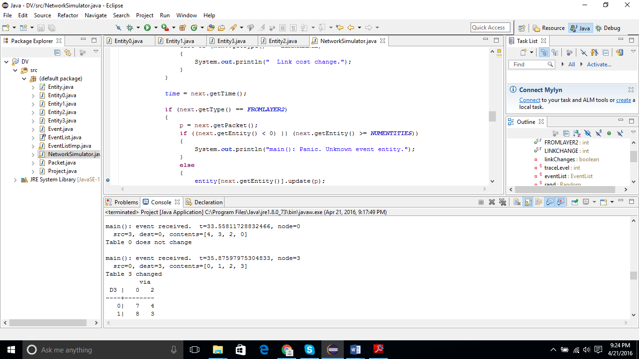

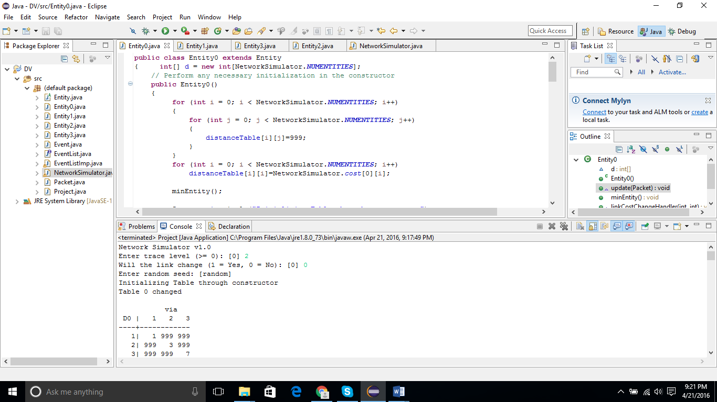

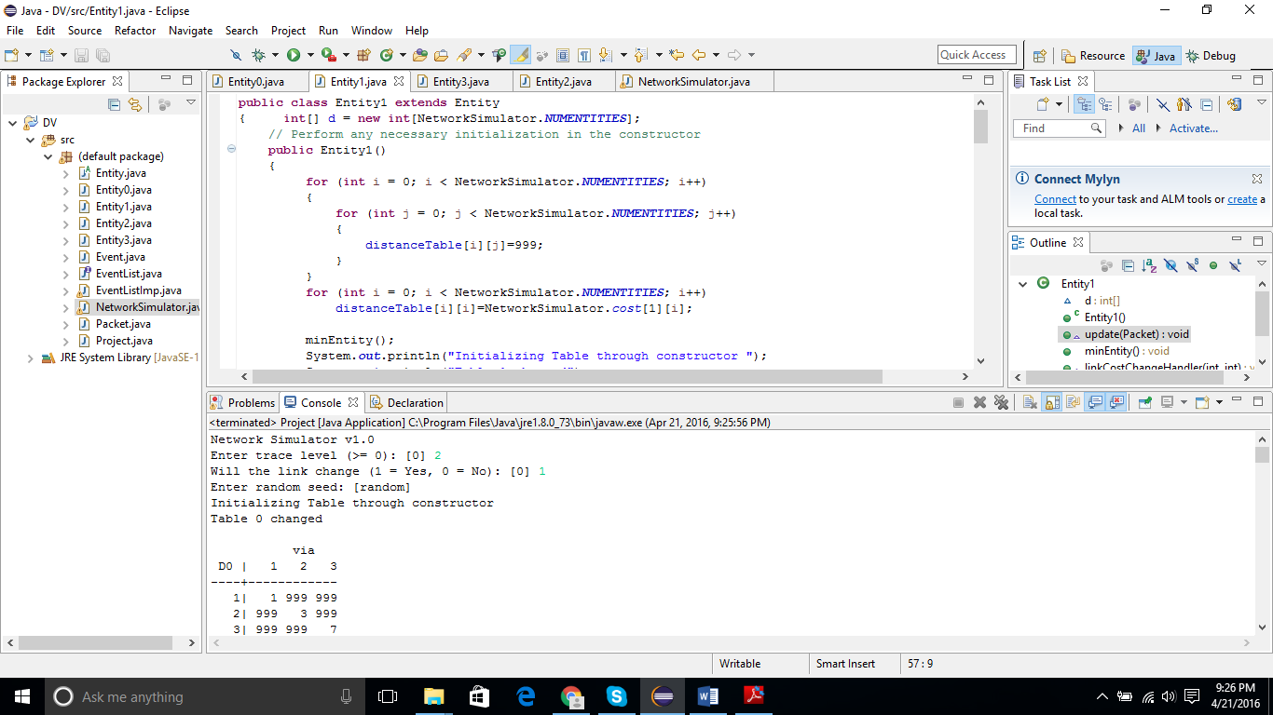

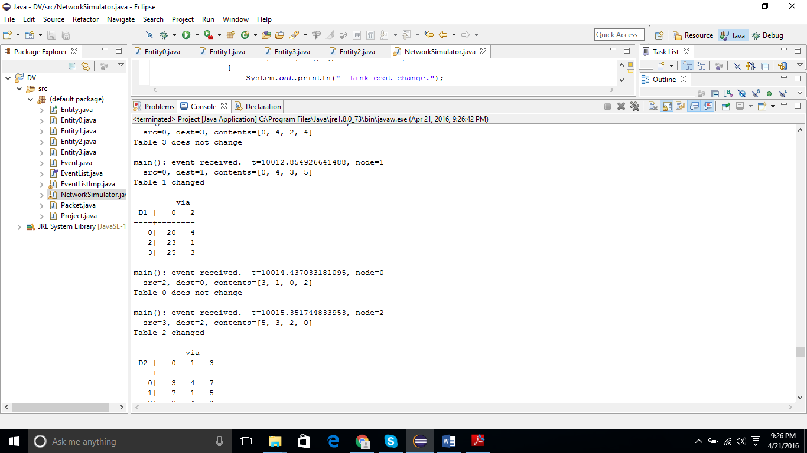

**Sample Output –**

Network Simulator v1.0

Enter trace level (>= 0): [0] 2

Will the link change (1 = Yes, 0 = No): [0] 1

Enter random seed: [random]

Initializing Table through constructor

Table 0 changed

via

D0 | 1 2 3

----+------------

1| 1 999 999

2| 999 3 999

3| 999 999 7

Initializing Table through constructor

Table 1 changed

via

D1 | 0 2

----+--------

0| 1 999

2| 999 1

3| 999 999

Initializing Table through constructor

Table 2 changed

via

D2 | 0 1 3

----+------------

0| 3 999 999

1| 999 1 999

3| 999 999 2

Initializing Table through constructor

Table 3 changed

via

D3 | 0 2

----+--------

0| 7 999

1| 999 999

2| 999 2

main(): event received. t=1.4947169380995045, node=0

src=3, dest=0, contents=[7, 999, 2, 0]

Table 0 changed

via

D0 | 1 2 3

----+------------

1| 1 999 999

2| 999 3 9

3| 999 999 7

main(): event received. t=1.980709928121219, node=0

src=1, dest=0, contents=[1, 0, 1, 999]

Table 0 changed

via

D0 | 1 2 3

----+------------

1| 1 999 999

2| 2 3 9

3| 999 999 7

main(): event received. t=3.567068736545031, node=3

src=2, dest=3, contents=[0, 0, 0, 0]

Table 3 changed

via

D3 | 0 2

----+--------

0| 7 2

1| 999 2

2| 999 2

main(): event received. t=4.719471584901695, node=2

src=1, dest=2, contents=[1, 0, 1, 999]

Table 2 changed

via

D2 | 0 1 3

----+------------

0| 3 2 999

1| 999 1 999

3| 999 999 2

main(): event received. t=4.997965607587583, node=2

src=0, dest=2, contents=[0, 1, 3, 7]

Table 2 changed

via

D2 | 0 1 3

----+------------

0| 3 2 999

1| 4 1 999

3| 10 999 2

main(): event received. t=5.2794950321069685, node=0

src=3, dest=0, contents=[2, 2, 2, 0]

Table 0 changed

via

D0 | 1 2 3

----+------------

1| 1 999 9

2| 2 3 9

3| 999 999 7

main(): event received. t=6.087981770326481, node=2

src=3, dest=2, contents=[7, 999, 2, 0]

Table 2 changed

via

D2 | 0 1 3

----+------------

0| 3 2 9

1| 4 1 999

3| 10 999 2

main(): event received. t=6.3731183184024705, node=0

src=2, dest=0, contents=[0, 0, 0, 0]

Table 0 changed

via

D0 | 1 2 3

----+------------

1| 1 3 9

2| 2 3 9

3| 999 3 7

main(): event received. t=6.396654647744222, node=2

src=0, dest=2, contents=[0, 1, 3, 7]

Table 2 does not change

main(): event received. t=6.761115198961761, node=3

src=2, dest=3, contents=[2, 1, 0, 2]

Table 3 changed

via

D3 | 0 2

----+--------

0| 7 4

1| 999 3

2| 999 2

main(): event received. t=6.822349810345062, node=1

src=0, dest=1, contents=[0, 1, 3, 7]

Table 1 changed

via

D1 | 0 2

----+--------

0| 1 999

2| 4 1

3| 8 999

main(): event received. t=7.252661111232892, node=3

src=0, dest=3, contents=[0, 1, 3, 7]

Table 3 changed

via

D3 | 0 2

----+--------

0| 7 4

1| 8 3

2| 10 2

main(): event received. t=7.913271363665018, node=1

src=2, dest=1, contents=[0, 0, 0, 0]

Table 1 changed

via

D1 | 0 2

----+--------

0| 1 1

2| 4 1

3| 8 1

main(): event received. t=10.543382238845819, node=2

src=3, dest=2, contents=[2, 2, 2, 0]

Table 2 changed

via

D2 | 0 1 3

----+------------

0| 3 2 4

1| 4 1 4

3| 10 999 2

main(): event received. t=11.51430511182099, node=1

src=2, dest=1, contents=[2, 1, 0, 2]

Table 1 changed

via

D1 | 0 2

----+--------

0| 1 3

2| 4 1

3| 8 3

main(): event received. t=13.064670553444689, node=0

src=1, dest=0, contents=[1, 0, 1, 8]

Table 0 changed

via

D0 | 1 2 3

----+------------

1| 1 3 9

2| 2 3 9

3| 9 3 7

main(): event received. t=13.68051237169242, node=3

src=2, dest=3, contents=[2, 1, 0, 2]

Table 3 does not change

main(): event received. t=13.70853787454536, node=2

src=1, dest=2, contents=[1, 0, 1, 8]

Table 2 changed

via

D2 | 0 1 3

----+------------

0| 3 2 4

1| 4 1 4

3| 10 9 2

main(): event received. t=14.153146624484352, node=0

src=1, dest=0, contents=[1, 0, 1, 1]

Table 0 changed

via

D0 | 1 2 3

----+------------

1| 1 3 9

2| 2 3 9

3| 2 3 7

main(): event received. t=14.391384264910823, node=2

src=3, dest=2, contents=[4, 3, 2, 0]

Table 2 changed

via

D2 | 0 1 3

----+------------

0| 3 2 6

1| 4 1 5

3| 10 9 2

main(): event received. t=15.425220527661383, node=0

src=3, dest=0, contents=[4, 3, 2, 0]

Table 0 changed

via

D0 | 1 2 3

----+------------

1| 1 3 10

2| 2 3 9

3| 2 3 7

main(): event received. t=15.84434257263848, node=0

src=2, dest=0, contents=[2, 1, 0, 2]

Table 0 changed

via

D0 | 1 2 3

----+------------

1| 1 4 10

2| 2 3 9

3| 2 5 7

main(): event received. t=16.107899580859282, node=3

src=0, dest=3, contents=[0, 1, 3, 7]

Table 3 does not change

main(): event received. t=16.17675232423392, node=1

src=0, dest=1, contents=[0, 1, 3, 7]

Table 1 does not change

main(): event received. t=16.295318053496292, node=2

src=0, dest=2, contents=[0, 1, 2, 7]

Table 2 changed

via

D2 | 0 1 3

----+------------

0| 3 2 6

1| 4 1 5

3| 10 9 2

main(): event received. t=17.24603900097134, node=1

src=0, dest=1, contents=[0, 1, 2, 7]

Table 1 changed

via

D1 | 0 2

----+--------

0| 1 3

2| 3 1

3| 8 3

main(): event received. t=17.530986589567682, node=3

src=2, dest=3, contents=[2, 1, 0, 2]

Table 3 does not change

main(): event received. t=18.574915245846263, node=0

src=2, dest=0, contents=[2, 1, 0, 2]

Table 0 does not change

main(): event received. t=19.747146884090306, node=3

src=2, dest=3, contents=[2, 1, 0, 2]

Table 3 does not change

main(): event received. t=20.316634781954143, node=1

src=2, dest=1, contents=[2, 1, 0, 2]

Table 1 does not change

main(): event received. t=21.490948225434355, node=3

src=2, dest=3, contents=[2, 1, 0, 2]

Table 3 does not change

main(): event received. t=21.654401462740346, node=0

src=2, dest=0, contents=[2, 1, 0, 2]

Table 0 does not change

main(): event received. t=21.79288348767317, node=3

src=0, dest=3, contents=[0, 1, 2, 7]

Table 3 changed

via

D3 | 0 2

----+--------

0| 7 4

1| 8 3

2| 9 2

main(): event received. t=22.56550822082864, node=2

src=1, dest=2, contents=[1, 0, 1, 1]

Table 2 changed

via

D2 | 0 1 3

----+------------

0| 3 2 6

1| 4 1 5

3| 10 2 2

main(): event received. t=22.761421816592765, node=2

src=0, dest=2, contents=[0, 1, 2, 7]

Table 2 does not change

main(): event received. t=23.566925702404248, node=3

src=2, dest=3, contents=[2, 1, 0, 2]

Table 3 does not change

main(): event received. t=23.935575006821367, node=2

src=3, dest=2, contents=[4, 3, 2, 0]

Table 2 does not change

main(): event received. t=24.018839119943884, node=0

src=1, dest=0, contents=[1, 0, 1, 3]

Table 0 changed

via

D0 | 1 2 3

----+------------

1| 1 4 10

2| 2 3 9

3| 4 5 7

main(): event received. t=24.159522347638788, node=0

src=3, dest=0, contents=[4, 3, 2, 0]

Table 0 does not change

main(): event received. t=25.610353892059152, node=2

src=1, dest=2, contents=[1, 0, 1, 3]

Table 2 changed

via

D2 | 0 1 3

----+------------

0| 3 2 6

1| 4 1 5

3| 10 4 2

main(): event received. t=26.33108325579343, node=3

src=2, dest=3, contents=[2, 1, 0, 2]

Table 3 does not change

main(): event received. t=26.340949830493116, node=1

src=0, dest=1, contents=[0, 1, 2, 7]

Table 1 does not change

main(): event received. t=27.246631337494648, node=0

src=1, dest=0, contents=[1, 0, 1, 3]

Table 0 does not change

main(): event received. t=27.846467043256254, node=0

src=2, dest=0, contents=[2, 1, 0, 2]

Table 0 does not change

main(): event received. t=27.984264001919325, node=2

src=1, dest=2, contents=[1, 0, 1, 3]

Table 2 does not change

main(): event received. t=28.56065184908789, node=2

src=3, dest=2, contents=[4, 3, 2, 0]

Table 2 does not change

main(): event received. t=29.04309151047497, node=1

src=2, dest=1, contents=[2, 1, 0, 2]

Table 1 does not change

main(): event received. t=30.271851576172345, node=3

src=2, dest=3, contents=[2, 1, 0, 2]

Table 3 does not change

main(): event received. t=30.52439711649539, node=0

src=2, dest=0, contents=[2, 1, 0, 2]

Table 0 does not change

main(): event received. t=30.699004729392005, node=2

src=0, dest=2, contents=[0, 1, 2, 3]

Table 2 changed

via

D2 | 0 1 3

----+------------

0| 3 2 6

1| 4 1 5

3| 6 4 2

main(): event received. t=30.87276296004066, node=3

src=0, dest=3, contents=[0, 1, 2, 7]

Table 3 does not change

main(): event received. t=31.868776842125985, node=3

src=2, dest=3, contents=[2, 1, 0, 2]

Table 3 does not change

main(): event received. t=33.049057413257444, node=0

src=2, dest=0, contents=[2, 1, 0, 2]

Table 0 does not change

main(): event received. t=33.81409567945455, node=0

src=3, dest=0, contents=[4, 3, 2, 0]

Table 0 does not change

main(): event received. t=34.34729286316674, node=1

src=2, dest=1, contents=[2, 1, 0, 2]

Table 1 does not change

main(): event received. t=35.52257961475037, node=1

src=0, dest=1, contents=[0, 1, 2, 3]

Table 1 changed

via

D1 | 0 2

----+--------

0| 1 3

2| 3 1

3| 4 3

main(): event received. t=35.742024251037364, node=2

src=0, dest=2, contents=[0, 1, 2, 3]

Table 2 does not change

main(): event received. t=36.699915207214694, node=3

src=2, dest=3, contents=[2, 1, 0, 2]

Table 3 does not change

main(): event received. t=37.50043670488185, node=0

src=2, dest=0, contents=[2, 1, 0, 2]

Table 0 does not change

main(): event received. t=38.49213685780495, node=3

src=0, dest=3, contents=[0, 1, 2, 3]

Table 3 changed

via

D3 | 0 2

----+--------

0| 7 4

1| 8 3

2| 9 2

main(): event received. t=39.072227785152286, node=1

src=0, dest=1, contents=[0, 1, 2, 3]

Table 1 does not change

main(): event received. t=39.99097943741933, node=3

src=0, dest=3, contents=[0, 1, 2, 3]

Table 3 does not change

main(): event received. t=41.365876613232, node=2

src=1, dest=2, contents=[1, 0, 1, 3]

Table 2 does not change

main(): event received. t=41.396252913311294, node=0

src=2, dest=0, contents=[2, 1, 0, 2]

Table 0 does not change

main(): event received. t=41.64408276348734, node=2

src=0, dest=2, contents=[0, 1, 2, 2]

Table 2 changed

via

D2 | 0 1 3

----+------------

0| 3 2 6

1| 4 1 5

3| 5 4 2

main(): event received. t=43.053774626058186, node=3

src=2, dest=3, contents=[2, 1, 0, 2]

Table 3 does not change

main(): event received. t=43.122909753417055, node=2

src=0, dest=2, contents=[0, 1, 2, 2]

Table 2 does not change

main(): event received. t=43.15212314350301, node=1

src=0, dest=1, contents=[0, 1, 2, 2]

Table 1 changed

via

D1 | 0 2

----+--------

0| 1 3

2| 3 1

3| 3 3

main(): event received. t=44.0798762355158, node=1

src=2, dest=1, contents=[2, 1, 0, 2]

Table 1 does not change

main(): event received. t=44.57132418434842, node=2

src=3, dest=2, contents=[4, 3, 2, 0]

Table 2 does not change

main(): event received. t=44.76655450716944, node=2

src=1, dest=2, contents=[1, 0, 1, 3]

Table 2 does not change

main(): event received. t=45.023551152478014, node=0

src=1, dest=0, contents=[1, 0, 1, 3]

Table 0 does not change

main(): event received. t=45.140841847887366, node=0

src=2, dest=0, contents=[2, 1, 0, 2]

Table 0 does not change

main(): event received. t=45.652815535561274, node=0

src=3, dest=0, contents=[4, 3, 2, 0]

Table 0 does not change

main(): event received. t=46.286320948056485, node=2

src=0, dest=2, contents=[0, 1, 2, 2]

Table 2 does not change

main(): event received. t=47.172016018425744, node=0

src=2, dest=0, contents=[2, 1, 0, 2]

Table 0 does not change

main(): event received. t=49.65530920670298, node=3

src=0, dest=3, contents=[0, 1, 2, 2]

Table 3 changed

via

D3 | 0 2

----+--------

0| 7 4

1| 8 3

2| 9 2

main(): event received. t=50.227080892080345, node=2

src=0, dest=2, contents=[0, 1, 2, 4]

Table 2 changed

via

D2 | 0 1 3

----+------------

0| 3 2 6

1| 4 1 5

3| 7 4 2

main(): event received. t=50.71335136950932, node=1

src=0, dest=1, contents=[0, 1, 2, 2]

Table 1 does not change

main(): event received. t=51.024871019980914, node=0

src=2, dest=0, contents=[2, 1, 0, 2]

Table 0 does not change

main(): event received. t=51.343663588850546, node=0

src=1, dest=0, contents=[1, 0, 1, 3]

Table 0 does not change

main(): event received. t=51.537359723834854, node=0

src=3, dest=0, contents=[4, 3, 2, 0]

Table 0 does not change

main(): event received. t=52.2089197850717, node=1

src=2, dest=1, contents=[2, 1, 0, 2]

Table 1 does not change

main(): event received. t=52.36338674426519, node=1

src=0, dest=1, contents=[0, 1, 2, 2]

Table 1 does not change

main(): event received. t=53.40947171996652, node=1

src=2, dest=1, contents=[2, 1, 0, 2]

Table 1 does not change

main(): event received. t=54.814981328209136, node=3

src=0, dest=3, contents=[0, 1, 2, 2]

Table 3 does not change

main(): event received. t=56.77941038208913, node=2

src=3, dest=2, contents=[4, 3, 2, 0]

Table 2 does not change

main(): event received. t=57.40970864743484, node=1

src=0, dest=1, contents=[0, 1, 2, 4]

Table 1 changed

via

D1 | 0 2

----+--------

0| 1 3

2| 3 1

3| 5 3

main(): event received. t=58.74404775066906, node=0

src=2, dest=0, contents=[2, 1, 0, 2]

Table 0 does not change

main(): event received. t=58.87075817813061, node=3

src=0, dest=3, contents=[0, 1, 2, 2]

Table 3 does not change

main(): event received. t=60.08266857856967, node=3

src=2, dest=3, contents=[2, 1, 0, 2]

Table 3 does not change

main(): event received. t=60.836671905214054, node=1

src=2, dest=1, contents=[2, 1, 0, 2]

Table 1 does not change

main(): event received. t=63.280545418850906, node=3

src=0, dest=3, contents=[0, 1, 2, 4]

Table 3 changed

via

D3 | 0 2

----+--------

0| 7 4

1| 8 3

2| 9 2

main(): event received. t=63.68171350538462, node=0

src=1, dest=0, contents=[1, 0, 1, 3]

Table 0 does not change

main(): event received. t=64.49293450606092, node=2

src=3, dest=2, contents=[4, 3, 2, 0]

Table 2 does not change

main(): event received. t=64.55377984202207, node=2

src=1, dest=2, contents=[1, 0, 1, 3]

Table 2 does not change

main(): event received. t=66.14788831249557, node=1

src=2, dest=1, contents=[2, 1, 0, 2]

Table 1 does not change

main(): event received. t=68.63073190884543, node=0

src=3, dest=0, contents=[4, 3, 2, 0]

Table 0 does not change

main(): event received. t=74.54235371197251, node=1

src=2, dest=1, contents=[2, 1, 0, 2]

Table 1 does not change

main(): event received. t=83.12442366968763, node=1

src=2, dest=1, contents=[2, 1, 0, 2]

Table 1 does not change

main(): event received. t=87.69134427204773, node=1

src=2, dest=1, contents=[2, 1, 0, 2]

Table 1 does not change

main(): event received. t=10000.0, node=0

Link cost change.

Table 0 changed

via

D0 | 1 2 3

----+------------

1| 20 4 10

2| 2 3 9

3| 4 5 7

via

D1 | 0 2

----+--------

0| 20 3

2| 3 1

3| 5 3

Table 1 changed

main(): event received. t=10001.389462706622, node=1

src=0, dest=1, contents=[0, 4, 2, 4]

Table 1 changed

via

D1 | 0 2

----+--------

0| 20 3

2| 22 1

3| 24 3

main(): event received. t=10006.314797281944, node=3

src=0, dest=3, contents=[0, 4, 2, 4]

Table 3 changed

via

D3 | 0 2

----+--------

0| 7 4

1| 11 3

2| 9 2

main(): event received. t=10006.525863509996, node=2

src=1, dest=2, contents=[3, 0, 1, 3]

Table 2 changed

via

D2 | 0 1 3

----+------------

0| 3 4 6

1| 4 1 5

3| 7 4 2

main(): event received. t=10007.541323522977, node=3

src=2, dest=3, contents=[3, 1, 0, 2]

Table 3 changed

via

D3 | 0 2

----+--------

0| 7 5

1| 11 3

2| 9 2

main(): event received. t=10008.436259505903, node=0

src=1, dest=0, contents=[3, 0, 1, 3]

Table 0 changed

via

D0 | 1 2 3

----+------------

1| 20 4 10

2| 21 3 9

3| 23 5 7

main(): event received. t=10008.657948358707, node=2

src=1, dest=2, contents=[3, 0, 1, 3]

Table 2 does not change

main(): event received. t=10008.861692676892, node=2

src=0, dest=2, contents=[0, 4, 2, 4]

Table 2 changed

via

D2 | 0 1 3

----+------------

0| 3 4 6

1| 7 1 5

3| 7 4 2

main(): event received. t=10010.467609848607, node=2

src=0, dest=2, contents=[0, 4, 3, 5]

Table 2 changed

via

D2 | 0 1 3

----+------------

0| 3 4 6

1| 7 1 5

3| 8 4 2

main(): event received. t=10010.669049991788, node=1

src=0, dest=1, contents=[0, 4, 3, 5]

Table 1 changed

via

D1 | 0 2

----+--------

0| 20 3

2| 23 1

3| 25 3

main(): event received. t=10011.153798348674, node=1

src=2, dest=1, contents=[3, 1, 0, 2]

Table 1 changed

via

D1 | 0 2

----+--------

0| 20 4

2| 23 1

3| 25 3

main(): event received. t=10011.709184974441, node=2

src=3, dest=2, contents=[4, 3, 2, 0]

Table 2 does not change

main(): event received. t=10012.305715069582, node=3

src=0, dest=3, contents=[0, 4, 3, 5]

Table 3 changed

via

D3 | 0 2

----+--------

0| 7 5

1| 11 3

2| 10 2

main(): event received. t=10012.811804312681, node=0

src=1, dest=0, contents=[3, 0, 1, 3]

Table 0 does not change

main(): event received. t=10013.347632489045, node=0

src=3, dest=0, contents=[4, 3, 2, 0]

Table 0 does not change

main(): event received. t=10013.37557770878, node=0

src=2, dest=0, contents=[3, 1, 0, 2]

Table 0 changed

via

D0 | 1 2 3

----+------------

1| 20 4 10

2| 21 3 9

3| 23 5 7

main(): event received. t=10013.927167686628, node=1

src=2, dest=1, contents=[3, 1, 0, 2]

Table 1 does not change

main(): event received. t=10014.690734834066, node=2

src=1, dest=2, contents=[3, 0, 1, 3]

Table 2 does not change

main(): event received. t=10016.516029476787, node=0

src=3, dest=0, contents=[5, 3, 2, 0]

Table 0 changed

via

D0 | 1 2 3

----+------------

1| 20 4 10

2| 21 3 9

3| 23 5 7

main(): event received. t=10016.566616472197, node=1

src=0, dest=1, contents=[0, 4, 3, 5]

Table 1 does not change

main(): event received. t=10018.454244983277, node=3

src=2, dest=3, contents=[3, 1, 0, 2]

Table 3 does not change

main(): event received. t=10020.237091160774, node=2

src=0, dest=2, contents=[0, 4, 3, 5]

Table 2 does not change

main(): event received. t=10020.495375295304, node=1

src=2, dest=1, contents=[3, 1, 0, 2]

Table 1 does not change

main(): event received. t=10020.60149780409, node=3

src=0, dest=3, contents=[0, 4, 3, 5]

Table 3 does not change

main(): event received. t=10020.722199027601, node=0

src=1, dest=0, contents=[3, 0, 1, 3]

Table 0 does not change

main(): event received. t=10021.595613084897, node=0

src=2, dest=0, contents=[3, 1, 0, 2]

Table 0 does not change

main(): event received. t=10021.631005538107, node=2

src=3, dest=2, contents=[5, 3, 2, 0]

Table 2 changed

via

D2 | 0 1 3

----+------------

0| 3 4 7

1| 7 1 5

3| 8 4 2

main(): event received. t=10022.302230956542, node=0

src=3, dest=0, contents=[5, 3, 2, 0]

Table 0 does not change

main(): event received. t=10024.22146243703, node=1

src=0, dest=1, contents=[0, 4, 3, 5]

Table 1 does not change

main(): event received. t=10024.41053111647, node=0

src=1, dest=0, contents=[4, 0, 1, 3]

Table 0 changed

via

D0 | 1 2 3

----+------------

1| 20 4 10

2| 21 3 9

3| 23 5 7

main(): event received. t=10024.427850480077, node=2

src=3, dest=2, contents=[5, 3, 2, 0]

Table 2 does not change

main(): event received. t=10024.646452411762, node=2

src=1, dest=2, contents=[4, 0, 1, 3]

Table 2 changed

via

D2 | 0 1 3

----+------------

0| 3 5 7

1| 7 1 5

3| 8 4 2

main(): event received. t=10025.718628044096, node=3

src=0, dest=3, contents=[0, 4, 3, 5]

Table 3 does not change

main(): event received. t=10026.525084113367, node=3

src=2, dest=3, contents=[3, 1, 0, 2]

Table 3 does not change

main(): event received. t=10027.14417248599, node=1

src=2, dest=1, contents=[3, 1, 0, 2]

Table 1 does not change

main(): event received. t=10027.299442624288, node=0

src=2, dest=0, contents=[3, 1, 0, 2]

Table 0 does not change

main(): event received. t=10029.019572790041, node=2

src=0, dest=2, contents=[0, 4, 3, 5]

Table 2 does not change

main(): event received. t=10030.905161941437, node=1

src=2, dest=1, contents=[3, 1, 0, 2]

Table 1 does not change

main(): event received. t=10031.832853500176, node=1

src=0, dest=1, contents=[0, 4, 3, 5]

Table 1 does not change

main(): event received. t=10034.43502683769, node=3

src=2, dest=3, contents=[3, 1, 0, 2]

Table 3 does not change

main(): event received. t=10035.012332317112, node=0

src=2, dest=0, contents=[3, 1, 0, 2]

Table 0 does not change

main(): event received. t=10035.558511646565, node=3

src=0, dest=3, contents=[0, 4, 3, 5]

Table 3 does not change

main(): event received. t=10035.574689001638, node=3

src=2, dest=3, contents=[3, 1, 0, 2]

Table 3 does not change

main(): event received. t=10035.751736205735, node=2

src=0, dest=2, contents=[0, 4, 3, 5]

Table 2 does not change

main(): event received. t=10038.531003328422, node=0

src=2, dest=0, contents=[3, 1, 0, 2]

Table 0 does not change

Simulator terminated at t=10038.531003328422, no packets in medium.